Your Bill of Rights
Now that you know a little about the Constitution, it's time to think about the Bill of Rights! The Bill of Rights are the first 10 amendments in the Constitution. These amendments guarantee citizens the individual liberties the Founding Fathers wanted to protect. Today, you will create your own Bill of Rights. Think about the 10 most important rights that you would want protected and put them on a poster.

Materials:
Computer Paper
Markers & Colored Pencils
Procedure:
Split your paper up into 10 boxes, each box you will fill with a right that you believe we should all have protected.
Include a visual representation for your rights
Guidelines:
You can work with up to two other people (at most, 3 in a group)
Make you Bill of Rights look good so we can hang them!
Today is the ONLY class period that you have to get this done, so get focused!

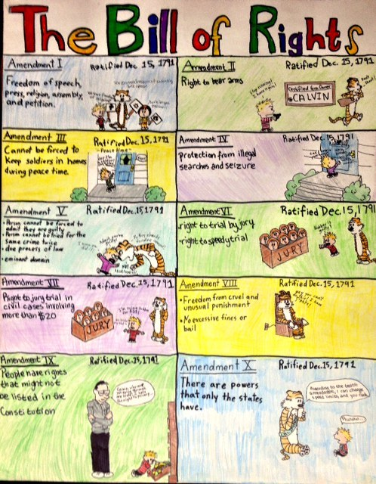
This is what your paper should look like!

